The Lower Back Pain Solution

If you’re reading this article it’s probably because you’ve got some form of pain in your lower back right? Maybe it started as just a tiny dull ache but now it’s gotten worse. It’s not quite excruciating but it’s chronic, and it’s starting to really get on your nerves. Well the good news is that you may be no more than four weeks and four simple exercises away from a significant improvement. So sit back (or better yet stand) and get ready to read your way to a pain free future!

What causes it?

The human back is a complex thing, and there are numerous reasons why you may have developed pain there. If you’re truly concerned then it may be best to start by speaking to a doctor and asking for an X-ray or MRI scan. You could also visit a chiropractor or physiotherapist to try and garner more information. Moreover, if the pain you’re experiencing is acute, i.e. has started suddenly after an activity of heavy lifting movement, then you absolutely must cease your activity and consult a health professional.

With that said, chronic lower back pain of a lesser intensity is becoming increasingly common, and there are more reported cases of this kind of lower back pain today than ever before. Logic would dictate, then, that there must be some underlying modern lifestyle factor causing a significant amount of these cases. Most commonly, the lifestyle factor in question is…sitting down. Yep, you read that right, sitting down.

Before you call me a quack please bear with me for two more minutes. Sitting down involves a certain posture of hip flexion (bending forwards) alongside relaxation of core abdominal stabilisers and the muscles of the buttocks. In other words the muscles that are supposed to be ‘switched on’ all day are turned off, and the muscles that are only meant to be used occasionally are almost always switched on! The result of this is muscular imbalance and postural deviation.

Your body, the clever thing that it is, will then find ways to compensate for your altered posture. The most common of these clever little compensations is prolonged use of the lower back muscles as stabilisers. This results in…you guessed it, lower back pain.

Lower Cross Syndrome (also known as Anterior Pelvic tilt)
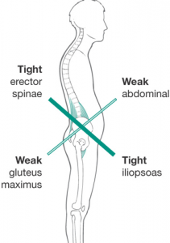

So how do we sort it?

The good news is, more than 60% of the people I have worked with have seen significant reductions in lower back pain by following my simple 4 exercise guide!

What we’re looking to do is stretch and loosen our tight muscles, whilst also strengthening our weak and loose muscles. Luckily you can do this with only 4 exercises, and it takes less than 10 minutes a day! Just start with a gentle jog or march on the spot to raise your pulse and get blood flowing.

Exercise 1: Lying Down Erector Spinae Stretch (you can do the straight leg or bent leg version!)

You’ll feel this stretch in your mid and lower back.

- Start by lying down on your back, hands out to the side and shoulders touching the floor
- Bring one leg over the other
- Bring the crossed over leg towards the ground, you can use your arm to assist if needed
- Try to keep your shoulders on the floor in order to get the best possible stretch

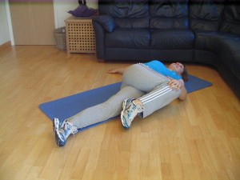

Straight leg version Bent Leg Version

Exercise 2: Iliopsoas (a.k.a Hip Flexors) stretch

- Start in a kneeling position with one leg out in front.
- Try to ‘tuck your bum under’ and squeeze your glutes (buttock muscles!)
- Lean forwards into the stretch
- Hold for at least 20-30 seconds
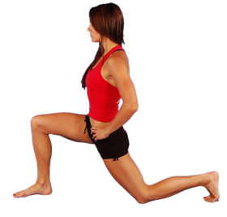

Exercise 3: Strengthening your CORE with the Plank

When most people say ‘abs’, they tend to mean the Rectus Abdominus or ‘six pack muscles’. However, these are NOT the muscles we are trying to develop right now (More on why in articles to follow) Instead we are trying to develop our DEEP CORE musculature, specifically our TVA, or transverse Abdominus, which acts as a stabiliser for our entire torso and spine.
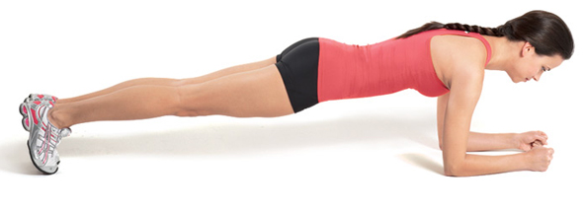

Key points

- Keep your stomach tight and think about drawing your belly button in towards your spine
- Keep your glutes (buttocks) contracted
- Maintain a nice straight line from head to toes (If in doubt get someone to watch you or record yourself with your phone)

Exercise 4: Strengthening your Glutes with the Glute Bridge

Strong buttock muscles help you run faster, move better and look more awesome! They also need to be strong to support your ‘Posterior Chain.’ If you have weak glutes then your other back muscles (i.e. your lower back) will have to do all the work. So the stronger we can get those glutes the better!

- Start lying on your back, feet flat on the floor and shoulder width apart
- Squeeze your buttock muscles to raise yourself up
- Hold for a couple of seconds, then slowly lower yourself back down to the start

What about Long-term prevention?

For most of us life, especially work life, involves sitting down for prolonged periods of time. But here are some quick tips to minimise the damage this can cause:

- Try not to sit for more than 30 minutes. All you need to do is get up and spend two minutes having a quick walk or shake around.

Have a look at the video below, at 1:06 to 3:05 I demonstrate a quick 2 minute mobility routine you can do to loosen up and re-energise your body!

https://www.youtube.com/watch?v=1SwCz0BQWIw

- Get a better desk or work station. Companies like google have started to provide alterable work desks where you can choose to stand as you work. See if your company will provide one. If you’re working at home or running your own small business, look into buying one for yourself. Yes they cost money but you’re investing in your own long term health and productivity.

- Eat better foods. I know what you’re thinking, how on earth does the food I eat impact the health of my lower back? Well I’m glad you asked. As you should know if you’ve been paying attention, Your DEEP CORE muscles work to stabilise your torso and spine to prevent back pain. The problem is, if you consume junk foods, excess sugars, processed foods and alcohol, you’re creating an inflammatory effect in your stomach. And when your stomach is inflamed, it prevents your core stabilisers from working properly. If you don’t believe me then test how long you can hold a plank the next time you’re feeling ill or having digestive issues. I dare you!

Let’s wrap this up

Right, I’ve given you four simple exercises (2 stretches and 2 strengthening movements) that will serve to correct your posture and relieve excess stress placed upon your lower back. I’ve also advised you not to sit for too long, to loosen up, to get a better work space and to eat better quality foods. If you’re really serious about minimising your lower back pain then get started today! You will most likely start feeling the benefits in less than four weeks, and even after your pain has gone you can continue to work these exercises into your weekly routine as preventative measures.

So there you go, you’ve got nothing to lose and everything to gain. Feel free to share this article with anyone you think it could help out, and let’s start getting pain free together.

If you have any questions or would like a bit more information, shoot an email over to alex@characterstrength.co.uk, or say hi on my question and answer page at http://www.facebook.com/CharacterStrength.

Healthy Regards

Alex

